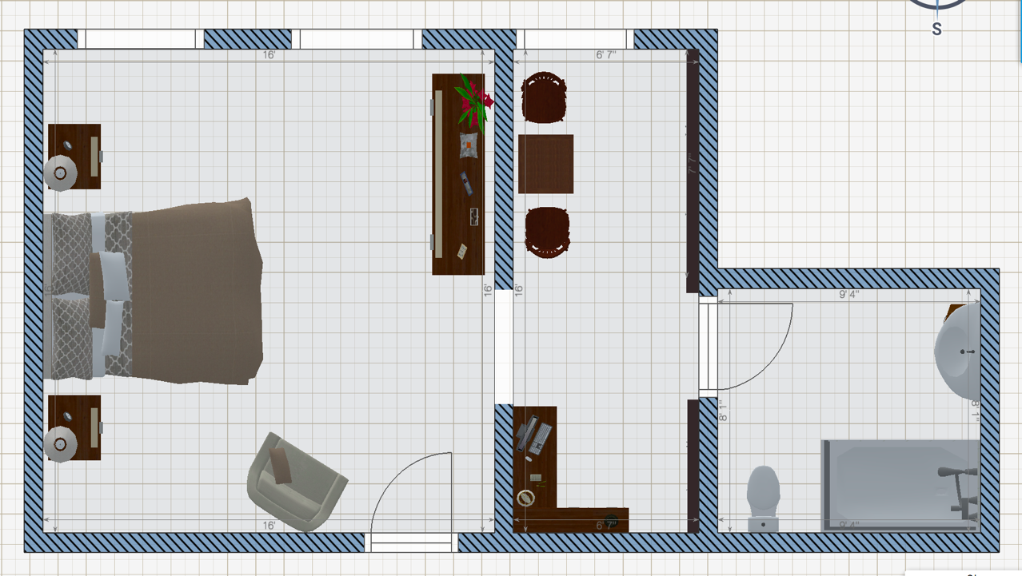
Suite 232

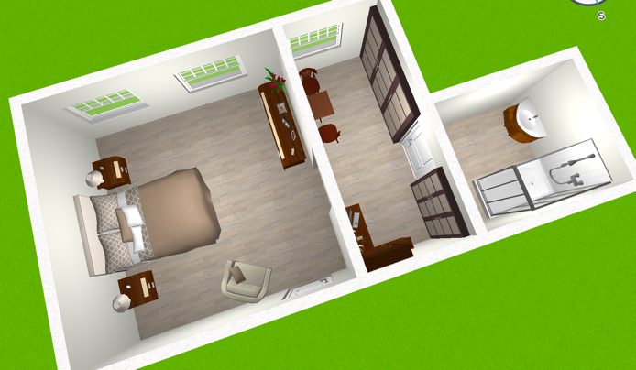
- Approx. 350sq,ft  - Private Suite  - Full Bath  - Centrally Located | - Mansion Zone  - Panoramic View  - Kitchenette  - Proximity to Nurse’s Station

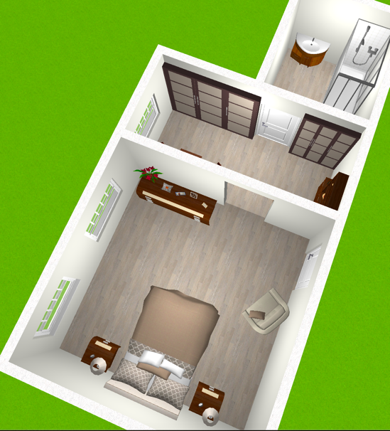

Available 1/20/ 2020
Starting at $3750/Month
*Sketch estimated scale based on current configuration

